POGIL Activity: Analyze an App for Bias
Students at Big Tech High School received a grant to create a city wide club. Members of the club learn the latest techniques in computer programming from mentors employed at technology companies in the area. The grant goals are to get a diverse group of motivated students access to internships, part time jobs and scholarships. Being a member is highly rewarding for students that fully commit to the program. Limited spots are available and the students want to make sure anyone who gets in has the time and ability to fully participate. For that reason, the students created an app to help select qualified applicants for interviews with area tech company representatives. They wanted to give preference to students that could drive or travel on mass transit safely on their own, determined by age. They also knew the time commitment would make it harder for someone that had to travel a long distance, and determined that zip codes could help filter applicants. The location the applicants need to travel to is in zip code 60640. The app requires users to enter their name, age, gender and zip code and makes a decision of whether they are accepted to a club.

Step1. In your POGIL team, download and install the Club App (apk or scan the QR code on left) on your mobile device. Run the app and enter the following test cases. Record whether or not the students were accepted to the club.

Name | Age | Gender | Zip | Accepted  (Yes or No)
Taylor Smith | 18 | F | 60640
Chris Johnson | 18 | M | 60643
Terry Williams | 16 | X | 60609
John Lee | 16 | M | 60640
Maria Brown | 17 | F | 60609
Luis Garcia | 17 | M | 60613
Cameron Miller | 13 | M | 60640
Lila Patel | 13 | F | 60613
Anna Rodriguez | 17 | F | 60660
Step 2: Use the zip code map below to mark which zip codes had students who were accepted or rejected.
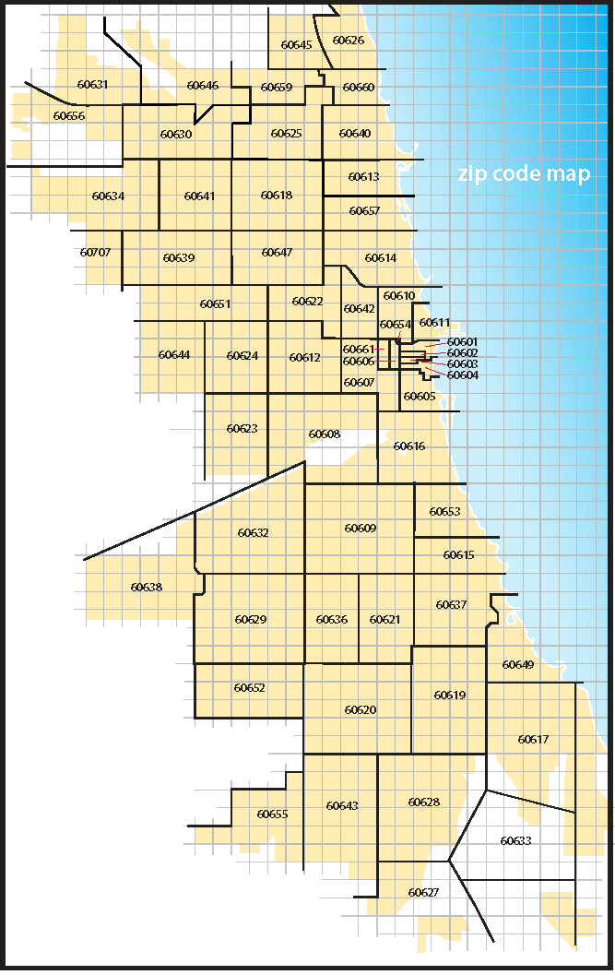
Step 3: Fill in the following Ethical Matrix for this app to determine the groups for which it works well or not well. Put in different groups such as female, male, 18 and older, under 16, close to the zipcode 60640, etc. and an approximate percentage 0-100% in the boxes for how well the app works for that group. Circle the groups for which the app might be biased.
Groups: | Accepted | Rejected | Positive Bias | Negative Bias | Fairness

Step 4 : Research Chicago census data. You may use the following links or search online. What patterns can you find in where different groups of people live? Do any of these patterns confirm your hypotheses about the app’s possible bias?
- https://en.wikipedia.org/wiki/Demographics_of_Chicago
- https://zipwho.com/

Step 5: Come up with at least 2 possible ways the program might have algorithmic bias against certain groups based on the results. Add those groups to your Ethical Matrix above if they are not there. Share your ideas with the whole class.
Possible Bias 1: ______________________________
Possible Bias 2: ______________________________

Step 6: Download the .aia file and import it into App Inventor. Look at the algorithm to see what features about the applicants are rated the highest. Predict the racial diversity of the club based on the steps above.

Step 7: One of the goals of the grant was a diverse group of students. How would you change the application algorithm to better meet the needs of the club? Consider each of the following.
- Data gathered in the application.
- Code in the app.
- Other ideas.
The suggested improvements should be shared with the class.

If your POGIL group has time, research another software application that may have algorithmic or data bias (there are some examples in the lesson’s Still Curious section) and create an Ethical Matrix for it that shows the groups for which it has positive or negative bias. Discuss how it could have a harmful effect on society, economy, or culture.

